

**CMPE 209-03**

**Network Security**

**Spring 2017**

**_____________________________________________________**

**Network Traffic Analyzer**

**Project Report**

Under the guidance of

**Prof. Chao-Li Tarng**

**Project Team 12**

**Rohit Kotalwar (010805080)**

**Vinay Puttanna (010699858)**

**Kshama Shalini (010763792)**

**Shivang Singh (010939851)**

- May 17, 2017 -

# Contents

|  |  |  |
| --- | --- | --- |
| **S. No.** | **Contents** | **Page No.** |
| 1. | Overview | 2 |
| 2. | Objective & Scope | 3 |
| 3. | Flow Diagram | 5 |
| 4. | Architecture of project model | 6 |
| 5. | Code Analysis | 7 - 13 |
| 6. | Environment Setup | 14 - 18 |
| 7. | Results | 19-24 |
| 8. | Future Work Suggestions | 25 |
| 9. | Conclusion | 26 |
| 10. | References | 26 |
| 11. | Individual Contribution | 27 |

# 

# 

# Overview

Network traffic analysis is the process which includes capturing, filtering and analyzing the filtered traffic. Analyzing the network traffic can reveal the important information related to network devices activities, type of data shared between them, bandwidth utilization for such transfer and for detecting anomalies.

Analyzing network traffic and detecting anomalies are the important tasks that need to performed at regular interval of time by security analysts. The large amount of traffic makes it difficult for the analyst to detect the anomalies in the network traffic.

Need for such type of system to analyze network traffic arises as the number of network attacks are increased. The different types of network attacks are carried out to obtain the unauthorized data. Attackers nowadays hosting a websites which contains malicious code, which when accessed can steal the important information such as user login credentials from the user's system.

Downloading the restricted content which is not legal and not proprietary which has copyright issues are the problems in the network systems. We need to trace such users to take correct actions against them. So need arises to develop such type of system which tracks the location of users.

The aim of our project is to build system which analyzes the network traffic and trace the user's location who are uploading or downloading the unauthorized data.

# Objectives and Scope

# **Objectives:**

# In this project, we are analyzing the traffic on a LAN (Local Area Network). We are parsing the already captured pcap file and we are extracting useful information out of it. Some of the main objectives that we implemented are:

1. Extracted the IP addresses of all blacklisted websites that are accessed
2. Extracted the IP addresses of users who are trying to access the blacklisted websites
3. Found the geographical locations of those IP addresses

**Scope:**

In this application, we are using a pcap file that is already captured using wireshark or tcpdump. We used dpkt python module to extract information from our packet capture file. We extracted IP address information of blacklisted websites as well as users who are trying to access those blacklisted websites.

After finding the IP addresses, we used ‘geolitecity’ database to map the IP addresses to their corresponding physical addresses. The database geolitecity.dat is a free version of database that is available on the internet. We used PyGeoIP, which is a python tool for getting this geolocation. We then generated the geolocations output in both KML (Keyhole Markup Language) format as well as CLI (Command Line) format.

Lastly, the KML files are mapped onto Google maps to visualize the locations in a better way. This shows the exact location of the websites on the map. We located the addresses of both malicious websites as well as users onto the google maps.

# ● pyGeoIP

# We used pyGeoIP to get the physical location of the IP addresses retrieved from the pcap file. PyGeoIP is a python tool that is used to retrieve geolocation information using IP addresses. It gives physical location that includes Country, region, city, organization, ISP and ASN. Geolitecity.dat is the database used by pyGeoIP to map the addresses.

# ● Wireshark :

# Wireshark is a network traffic analyzer which is used to sniff and analyze the packets.

# ● Dpkt Python Module:

# Dpkt python module is used to parse the pcap file and retrieve information. We used dpkt to retrieve IP addresses of blacklisted websites as well as the users who are trying to access those websites.

# ● Python

# We used Python as our scripting language to develop our network traffic analyzer application.

# Flow Diagram:

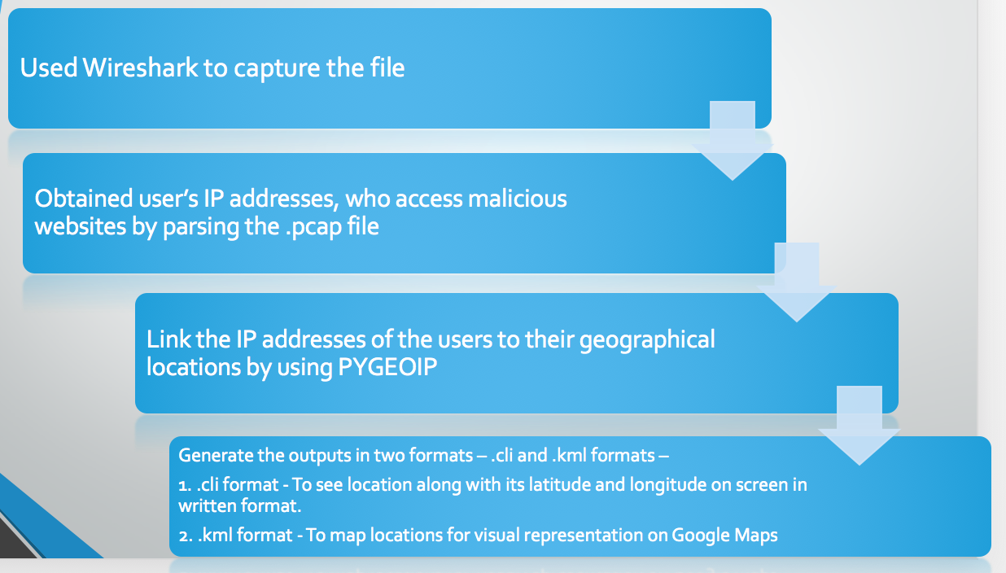

Flowchart of implementation of Network Traffic Analyzer

Architecture of project model

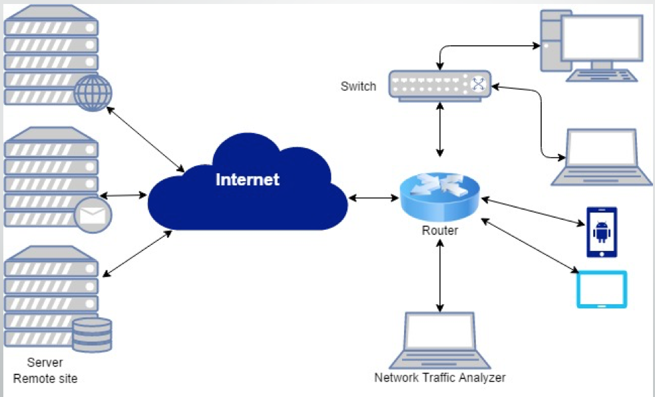

The Project Architecture, showing all components utilized

The Network Traffic analyzer sniffs the packets from the Router, In our case we will be using wireshark to sniff the packets. The application is installed on the Network Traffic Analyzer which parses the PCAP file and provide the desired results. All the devices access the websites which are located at remote locations.

# Code Analysis

We will be using following python libraries to develop application.

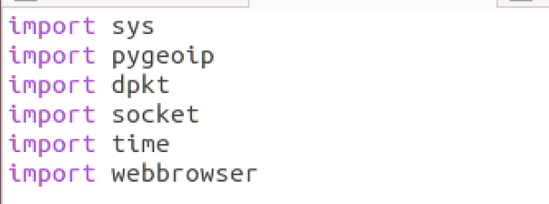

Set of Blacklisted ip address which will be checked with the each packet in PCAP file.



This is function used to display the information of the users who are a accessing the blacklisted websites.

The information such as City name, Region code, Country name, Longitude and Latitude values.

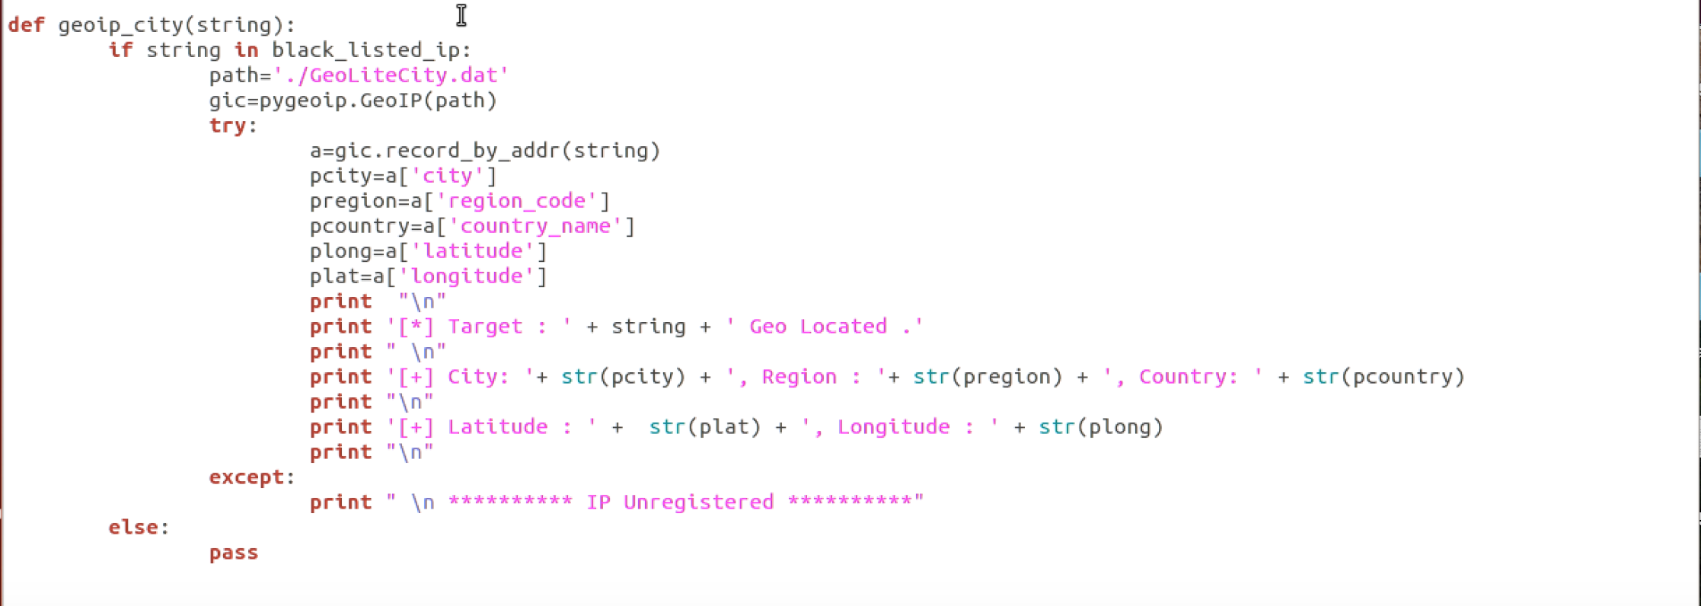

This function is used to store the all the above retrieved user’s information in one string in a dictionary.

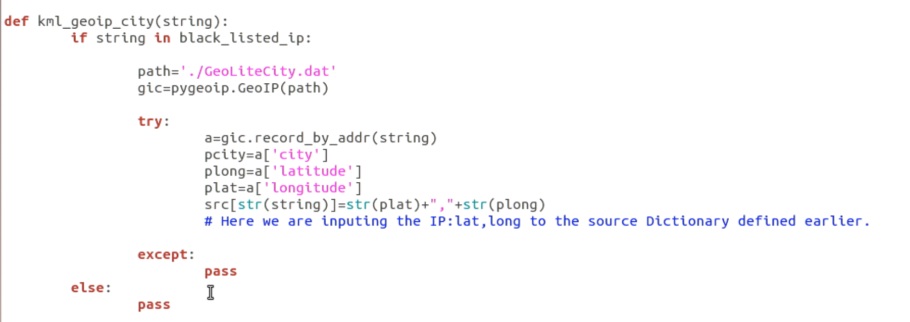

This function is used to store the all the above retrieved malicious websites information in one string in a dictionary.

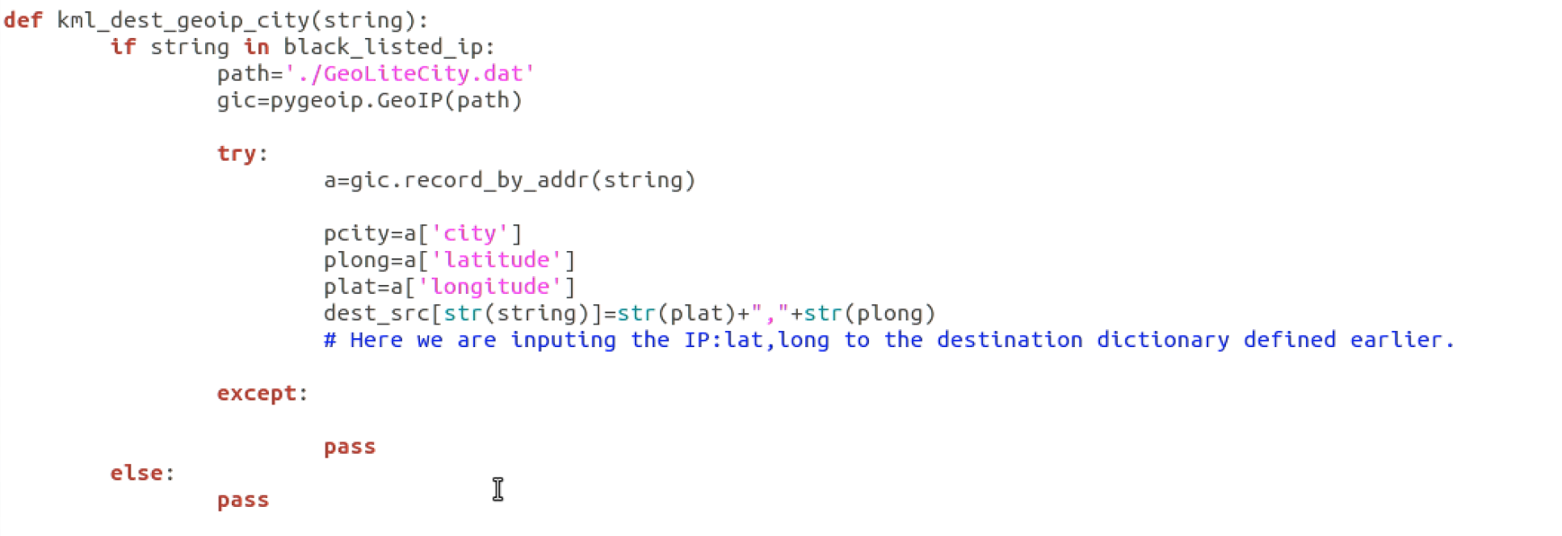

This function is used to display the user’s ip address with destination ip address who are accessing the malicious websites.

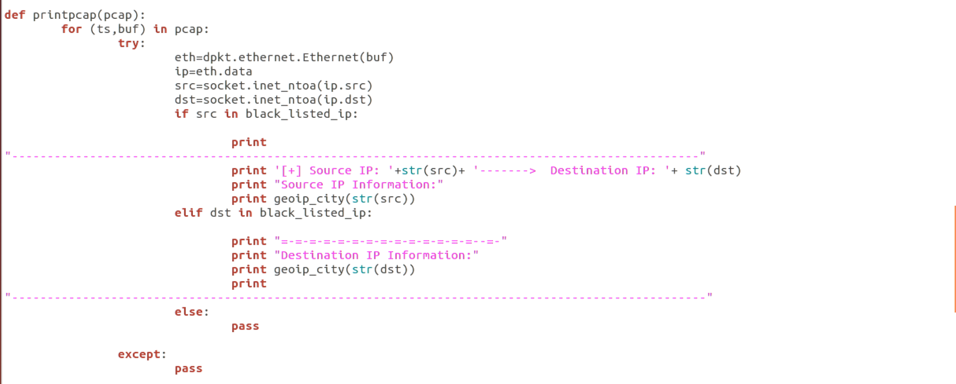

This function is used to parse each line of PCAP file and retrieve the source and destination ip address, we will be using dpkt module to parse the packets.

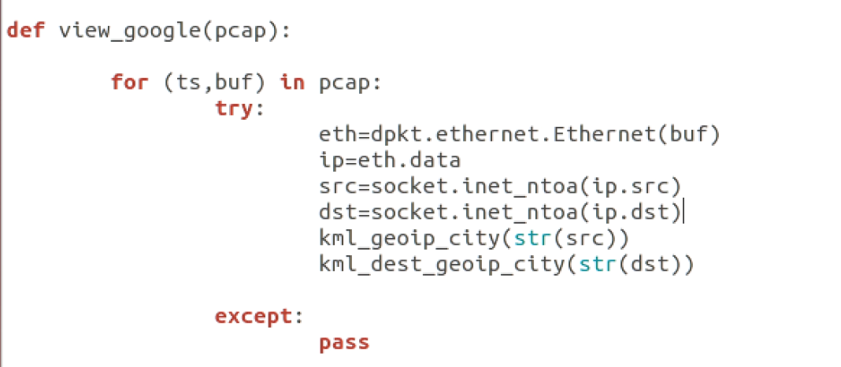

This function is used to create the KML data for the user’s ip address who are accessing malicious blacklisted websites and the ip address of blacklisted websites.

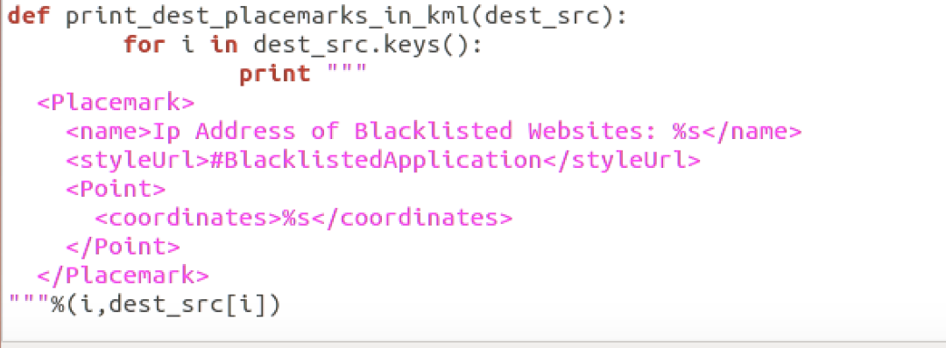

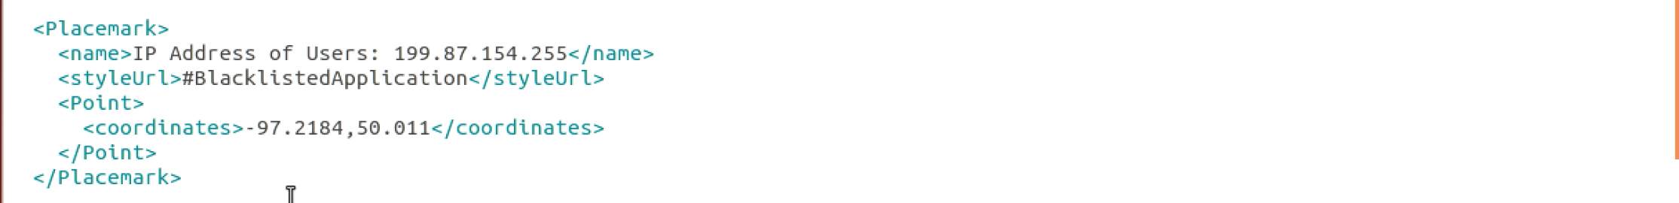

Creating the maps to display the location of blacklisted websites and the users who are accessing the blacklisted websites.

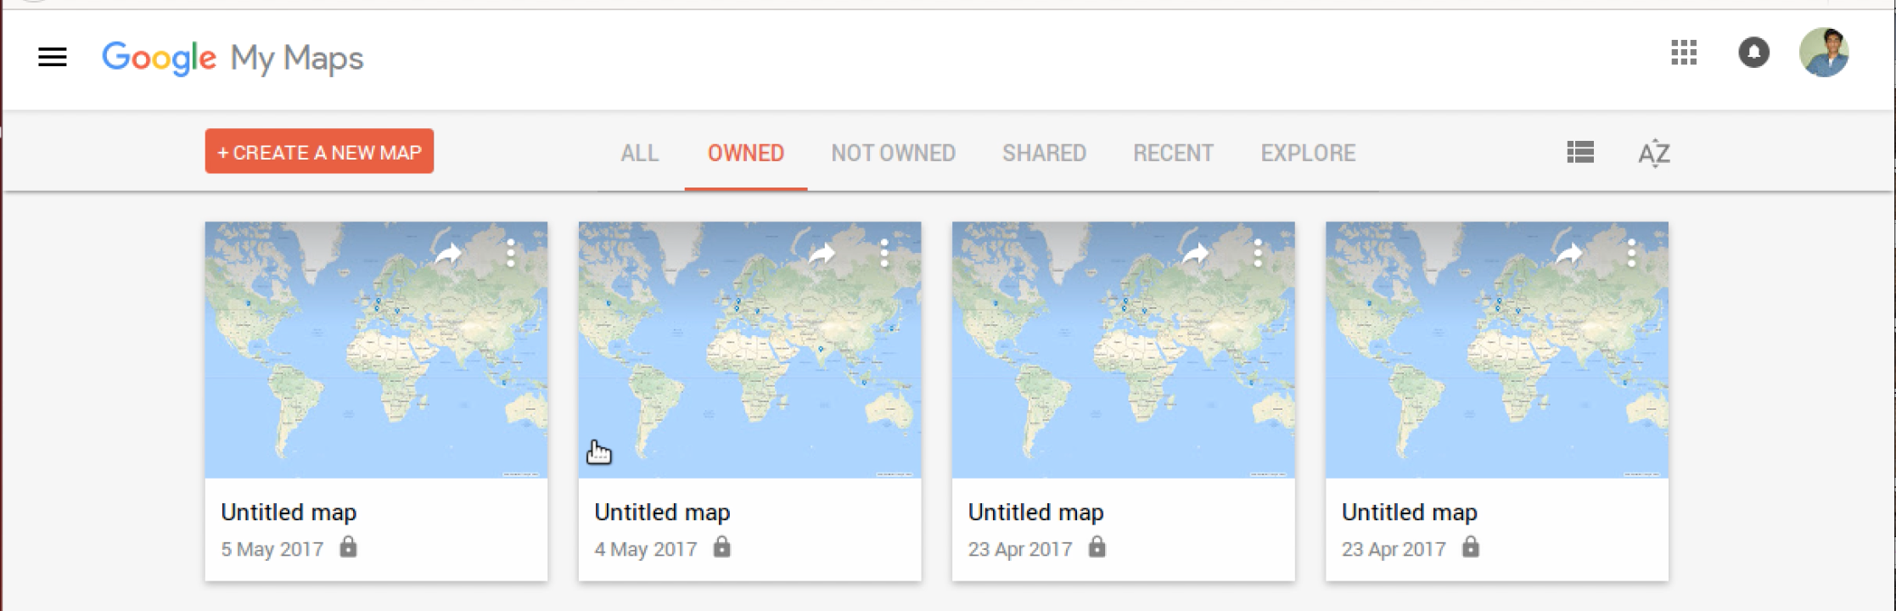

Passing the above generated kml data to the google maps.

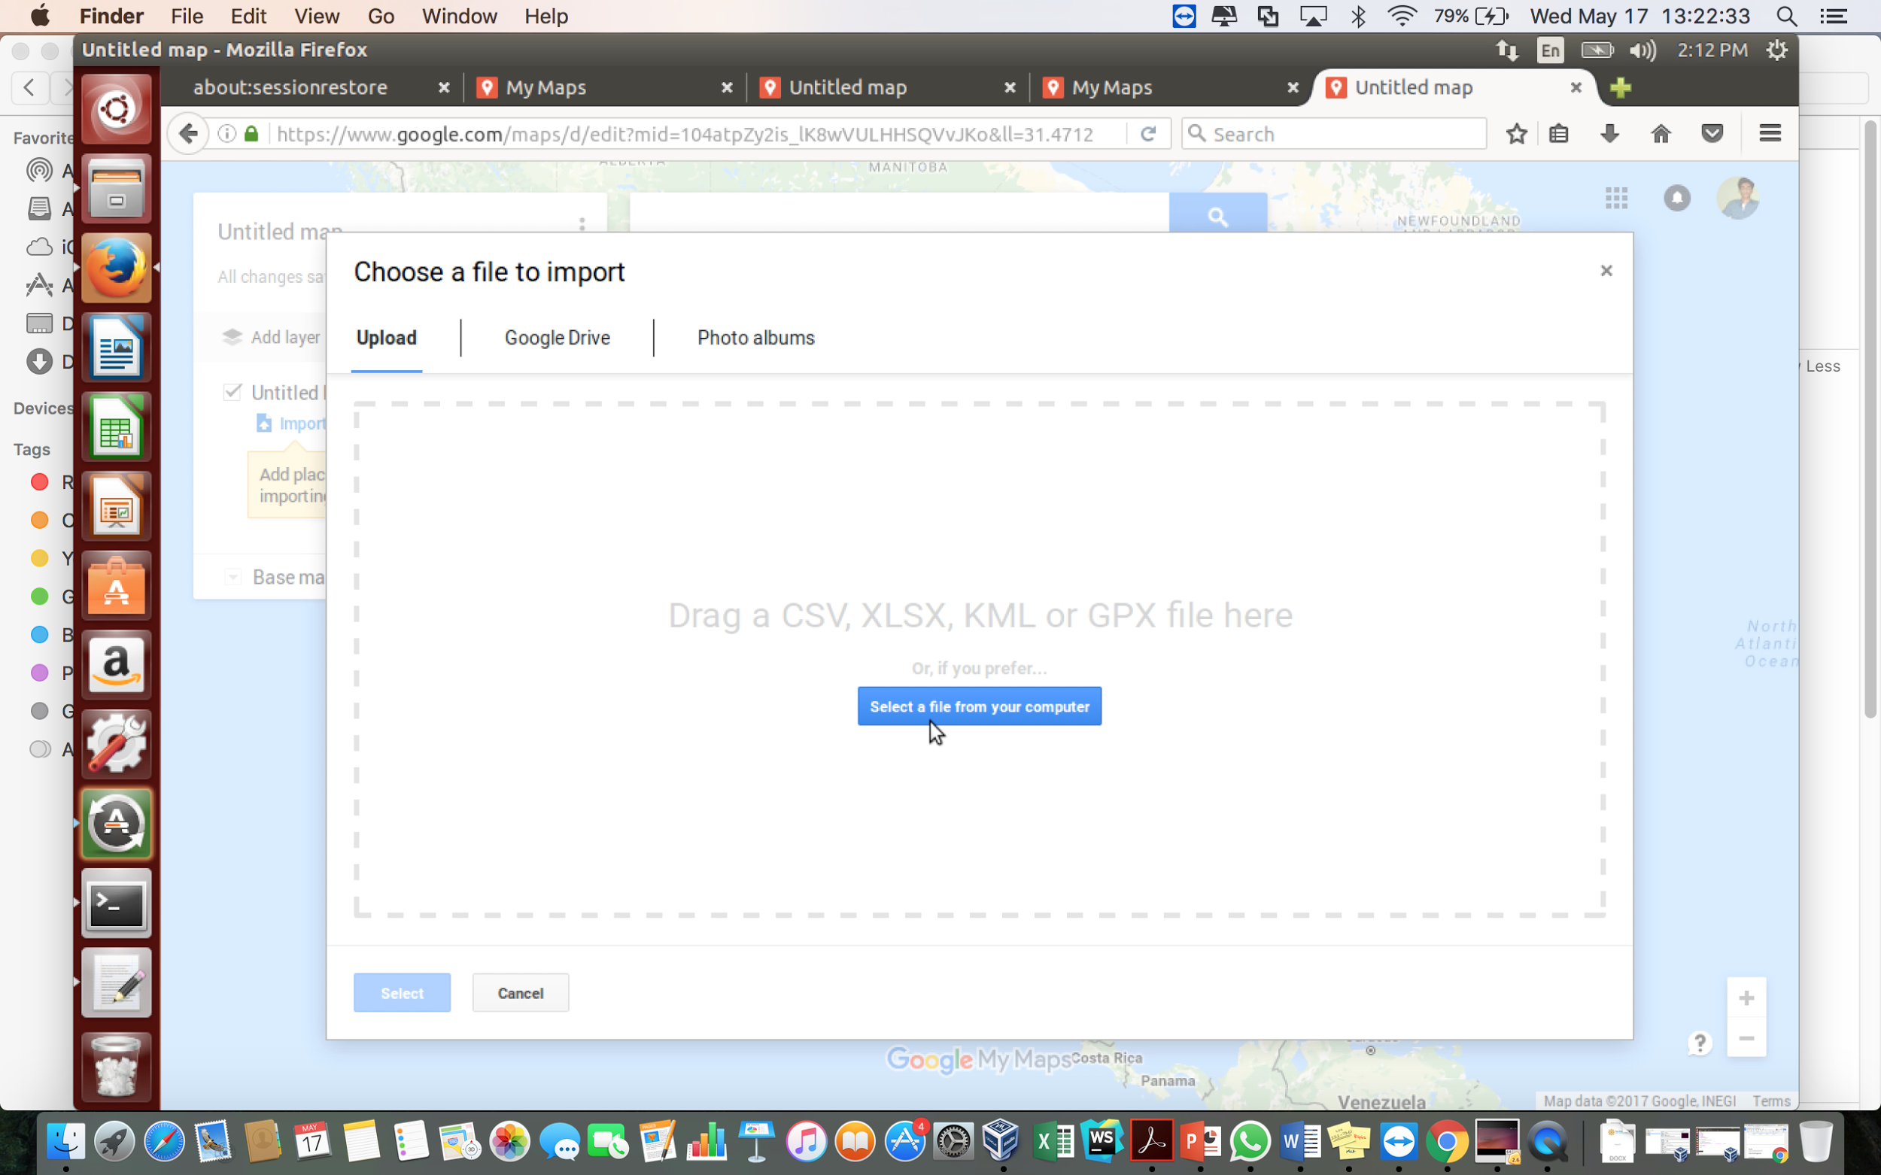

Displaying the location of Blacklisted websites.

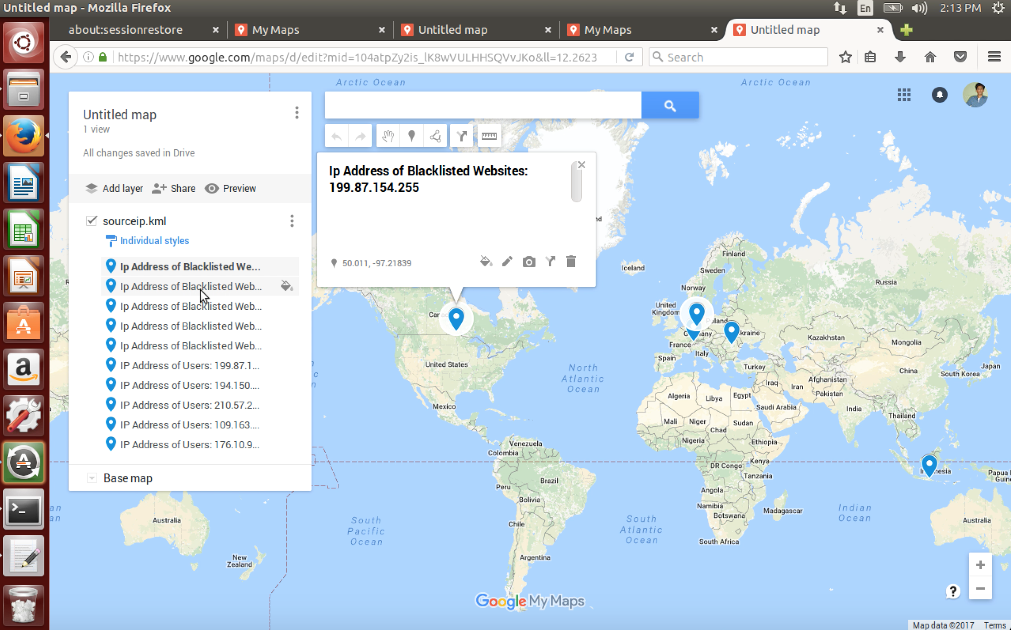

Displaying the location of the users who are accessing the blacklisted websites.

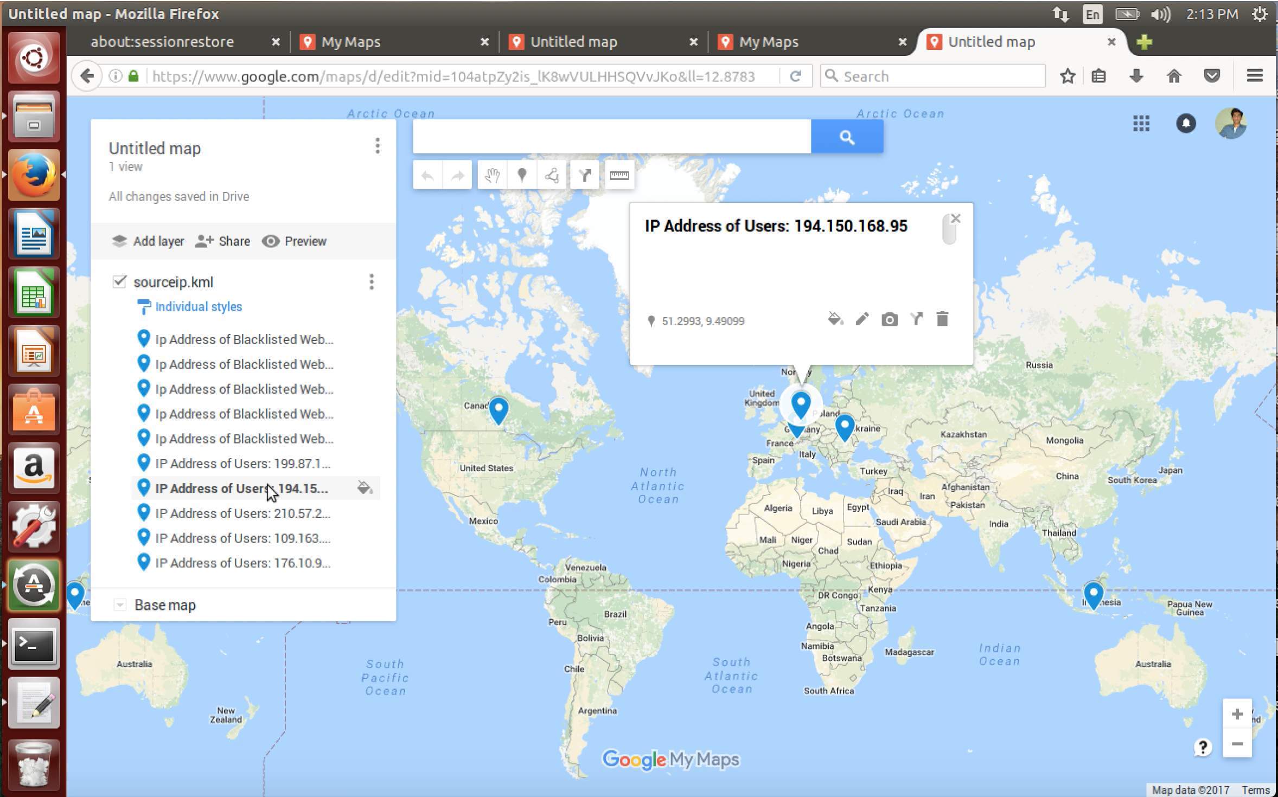

Script to analyze the Http Traffic.

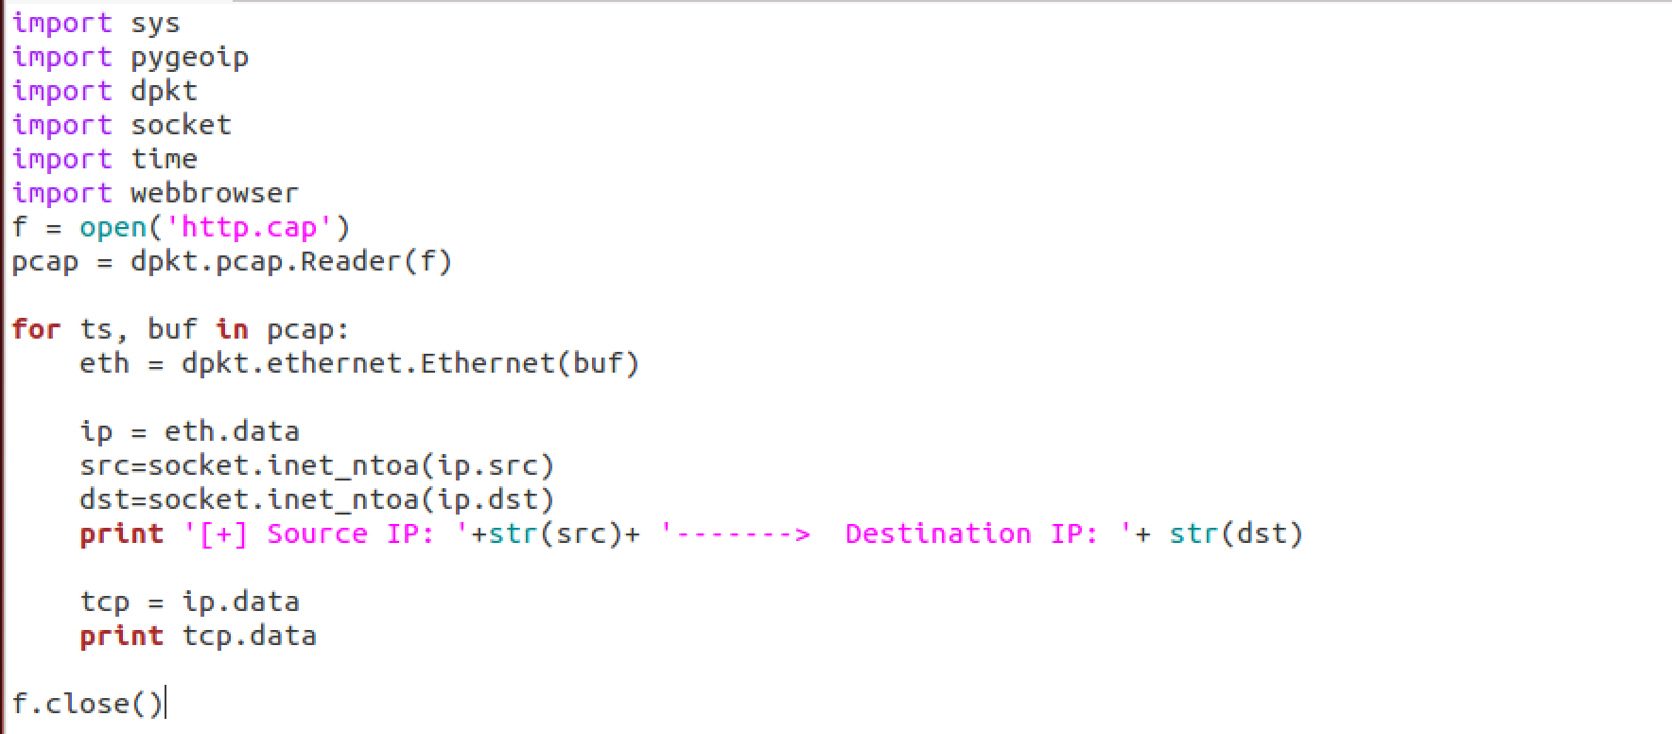

Displaying the HTTP request by user whose ip address is 145.254.160.237 to the server whose ip address is 65.208.228.223 for development.html web page.

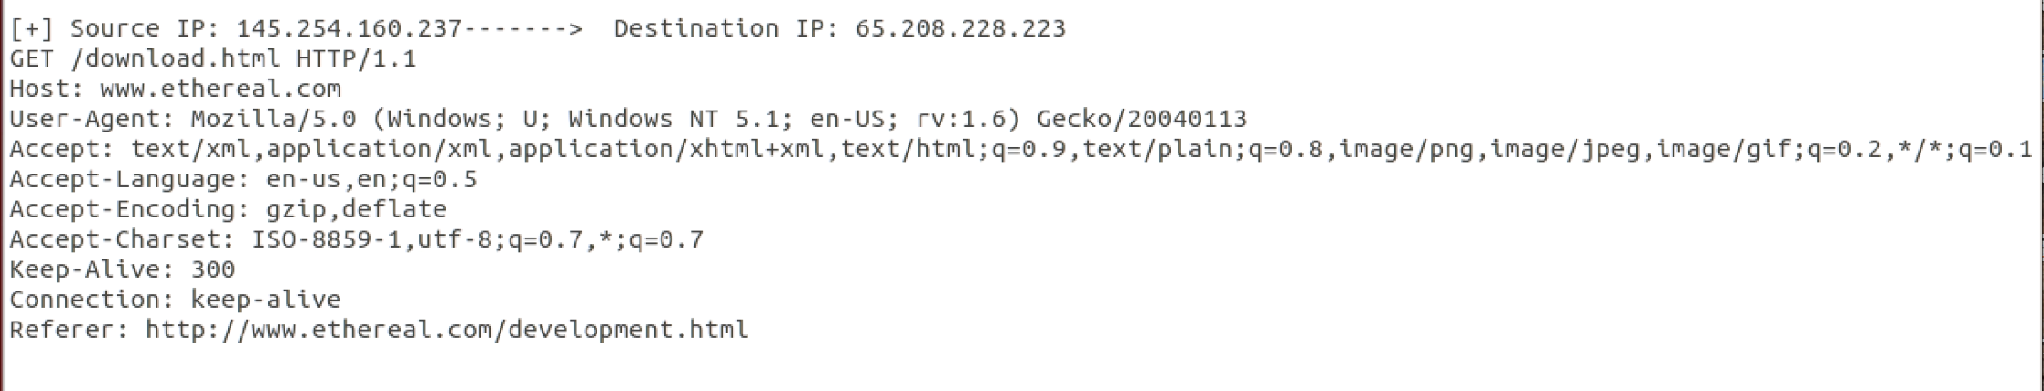

Displaying the HTTP response by server to the users with requested web page.

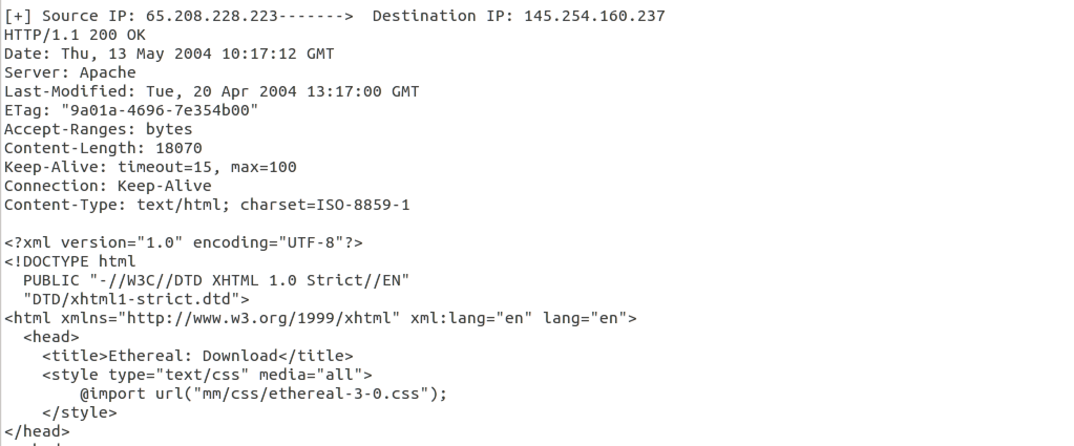

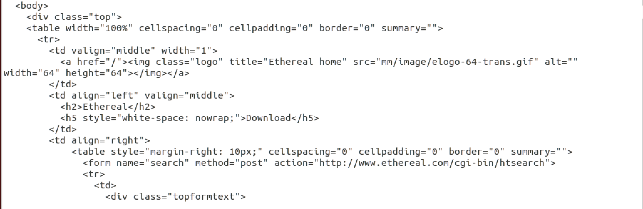

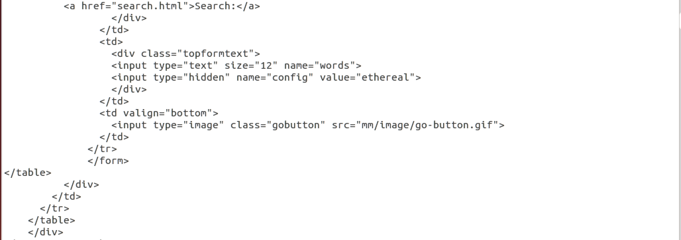

# Environment setup

Several tools have been utilized to achieve the goal of our project. The environment for the project has been setup using the following steps:

1. Download and install VMWare Workstation Pro 12.5 limited edition from https://my.vmware.com/en/web/vmware/info/slug/desktop_end_user_computing/vmware_workstation_pro/12_0

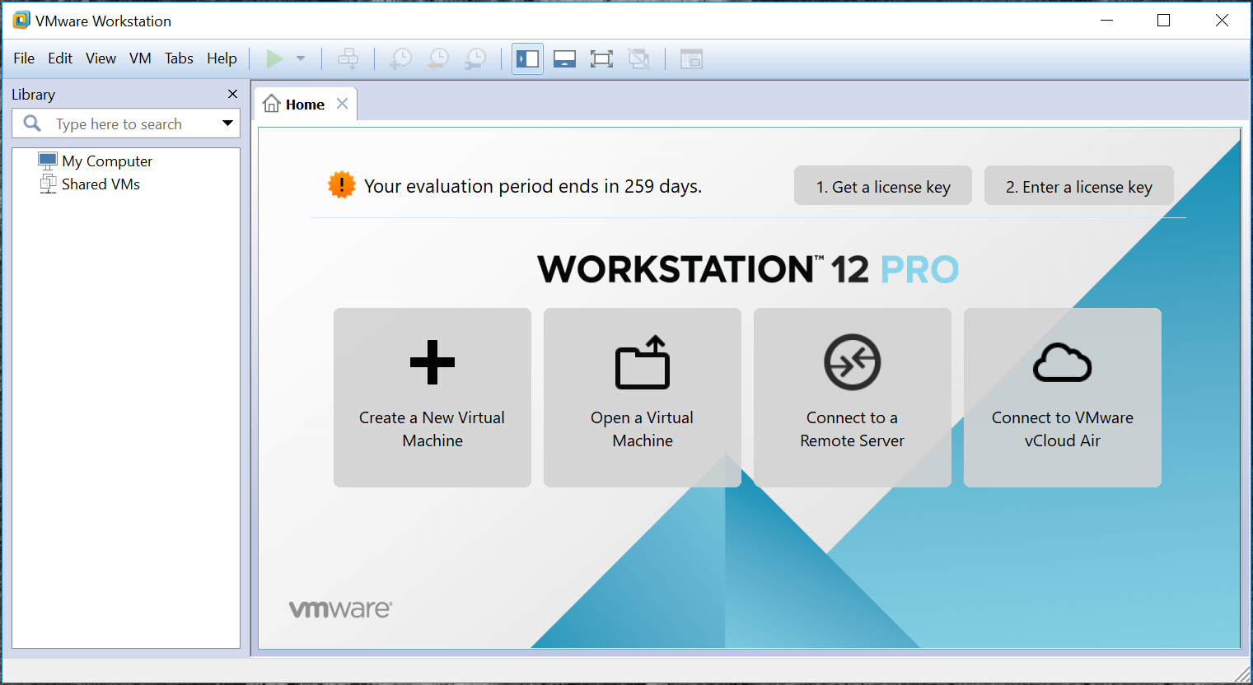

2. Download Ubuntu 16.04 LTS Desktop OS ISO image (64-bit) from https://www.ubuntu.com/download/desktop

3. Create a new Virtual Machine in the VMWare Workstation Pro

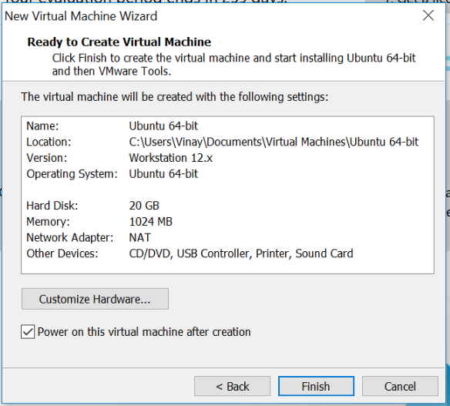

4. Install Ubuntu 16.04 on the VM.

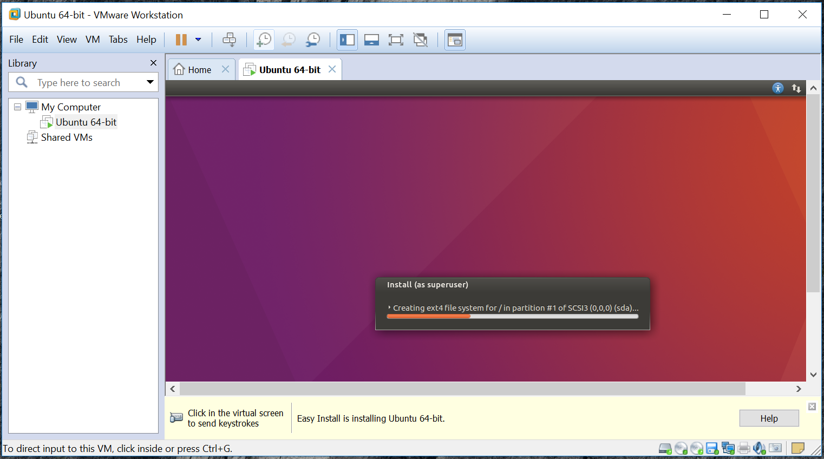

5. Install Wireshark network protocol analyzer tool on Ubuntu OS

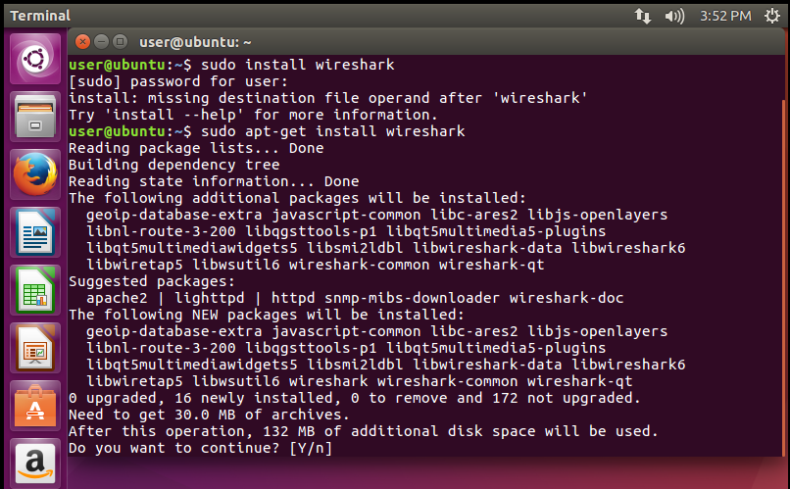

6. Install python pip package manager on Ubuntu OS

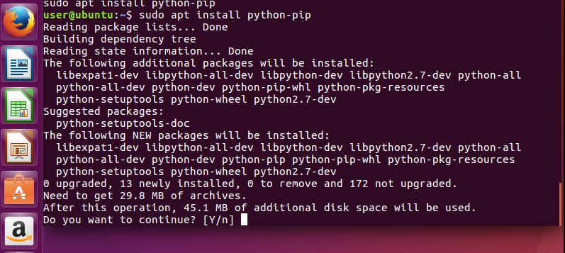

7. Install dpkt python packet creation/parsing tool on Ubuntu OS

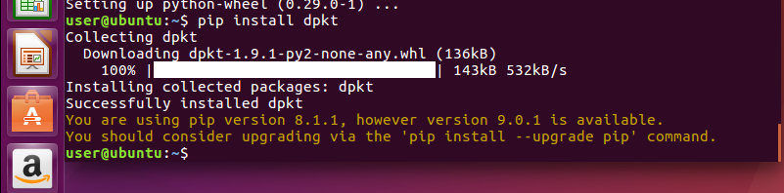

8. Install pyGeoIP python IP geolocation tool on Ubuntu OS

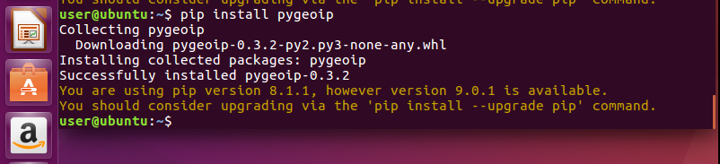

# 

# 

# 

# 

# 

# 

# 

# 

# Results

The goal of our network security project was to conduct a passive attack on the LAN by performing network traffic analysis using a network protocol analyzer tool. This was followed by the detailed analysis of the packet captures to detect whether blacklisted websites were accessed by the LAN users and identify the geographical locations of those users and the websites. Also, we have analyzed the HTTP traffic in the capture file and are able to identify the HTTP Request and HTTP Response contents to monitor user behaviour on using the Internet.

Our approach was an attempt in the field of network security to identify and prevent illegal activities such as visiting and downloading inappropriate content from the Internet. This act is termed as Cyberslacking. Inappropriate contents include but not limited to media elements such as audio and video files causing copyrights violation, pornography, prohibited resources etc. We have utilized several network security tools to accomplish the goal of the project. We have developed a program using Python programming language to parse the network capture (.pcap) file obtained at the LAN interface using dpkt python package. The tool extracted IP addresses from the file and filtered those addresses that have been classified as potential blacklisted websites. Later, we have used the pyGeoIP geolocation tool to get the geographical locations of the blacklisted websites and their users.

The implementation steps of the project are as described below:

1. To perform network traffic analysis, we need a network packet capture file. Wireshark is the most popular network protocol analyzer tool which has been used to capture packets at the LAN interface. The following figure shows the packet capture setup.

The following figure shows the packet capture by Wireshark packet capture tool

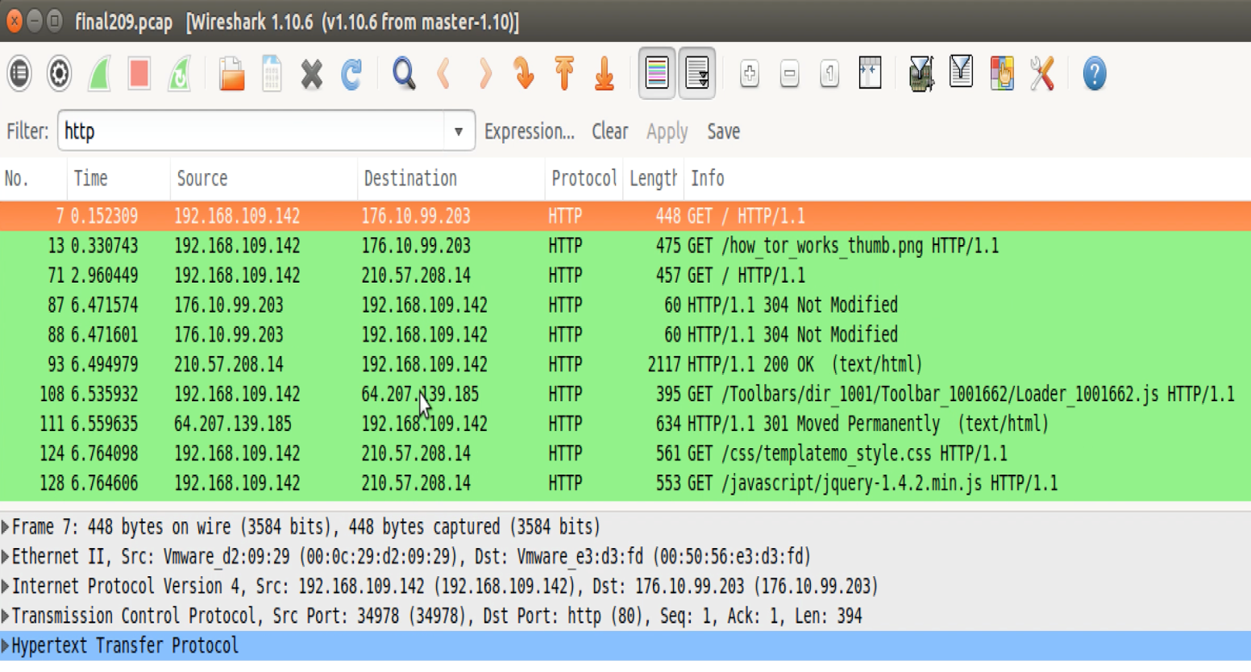

The Python parser application reads the pcap file and extracts source and destination IP addresses from all the packets. The extracted destination IP addresses are checked against the list of blacklisted IP addresses. If there is an address match, then the corresponding source and destination IP addresses are used to obtain the geographical location information using pyGeoIP python module and the geo location details are printed to the output.

The results of the python parser application can be displayed in two output formats as follows:

1. **Command Line Interface (CLI) format**

The following figure shows the CLI format output from the python parser application

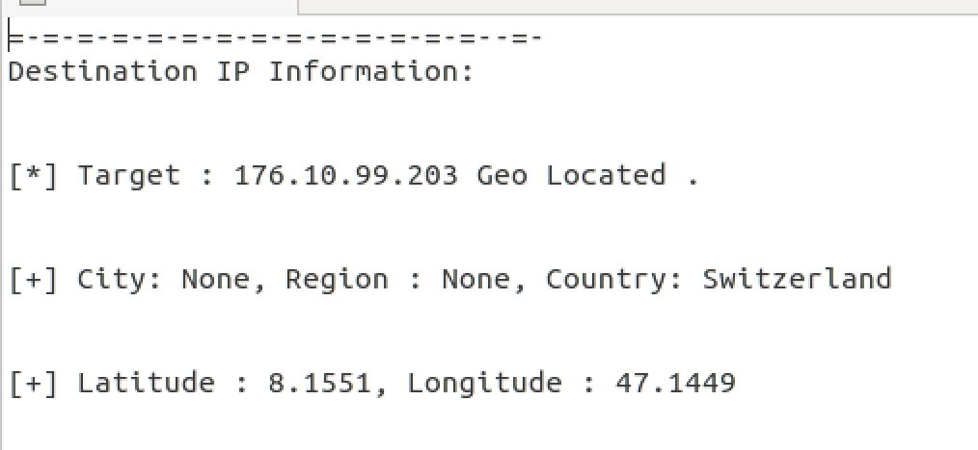

The output consists of -

* the destination IP address that belongs to the blacklisted category
* the city, region and country which the IP address belongs to
* the latitude and longitude values of the IP geolocation

The above set of information can be used to know the location of the blacklisted website to take appropriate legal action to control its operation and thus prevent cyberslacking.

**2. Keyhole Markup Language (KML) format**

The following figure shows the KML format output from the python parser application

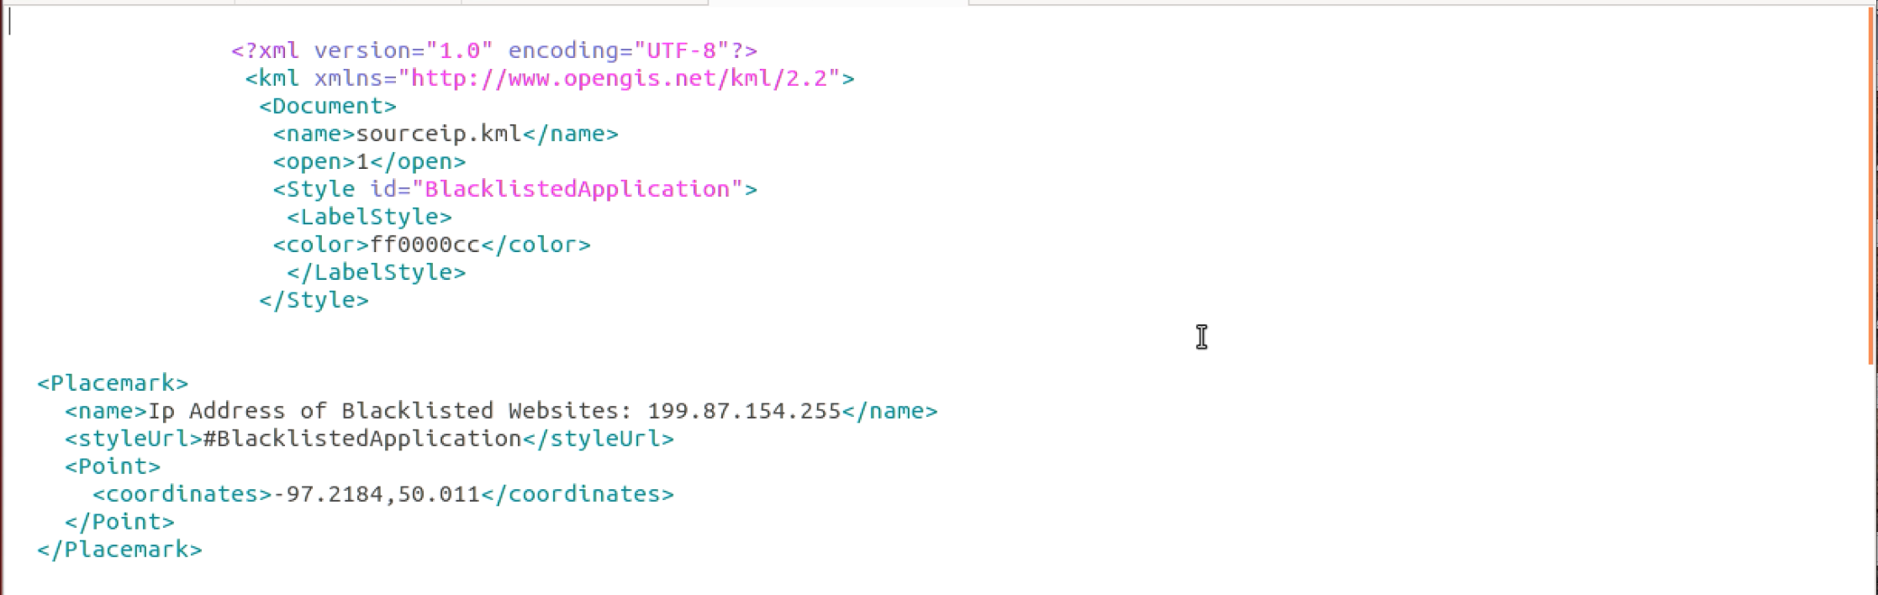

Keyhole Markup Language (KML) is the XML notation markup language developed by Google to display geo location on Maps using latitude and longitude values. The Python parser application reads the pcap file and extracts source and destination IP addresses from all the packets. The extracted destination IP addresses are checked against the list of blacklisted IP addresses. If there is an address match, then the corresponding source and destination IP addresses are used to obtain the geographical location information using pyGeoIP python module. This geo location information consisting of latitude and longitude is used to build the KML file as shown above.

The KML file is then loaded onto Google Maps to display IP locations with map-marker icons representing every source or destination IP address either accessing or belonging to the blacklisted category of websites. The Google Maps output upon loading KML file is as shown below.



From the above Google Maps, geo locations of users accessing blacklisted websites and the blacklisted websites can be found. This information can be used to adopt preventive measures to control blacklisted sites by local legal authorities thereby preventing cyberslacking.

### HTTP Traffic analysis

In addition to finding the geolocations of blacklisted IP addresses, our project also focuses on analyzing the HTTP traffic in the pcap file. This approach is adopted to analyze the user behaviour on the

Internet. The following figure shows the sample HTTP Request and Response in a packet in the capture file.

The following screenshot the HTTP Request obtained in the packet from the pcap file.



The following screenshot shows the HTTP Response obtained in the packet from the pcap file.



The following screenshot shows the HTML body content in the HTTP Response obtained from the packet in the pcap file.





From the above HTTP traffic analysis, the user behaviour on the Internet usage can be understood and if required, necessary actions can be initiated to ensure safe Internet usage that abides by the organization policy.

# Future Work Suggestions

The scope of our project can be extended in the following ways:

1. Adding more functionalities to the current features
2. Adding new features
3. Adding more functionalities to the current features

Currently, we are using GeoLiteCity database by MaxMind.com which is a free version. It can be replaced by GeoIP database which is a commercial complete version of the IP geo location database. This database provides more accurate geographical location of blacklisted websites and its users.

The application has been deployed and tested on the local machine. This can be deployed on the cloud infrastructure such as Amazon AWS to be accessed from multiple systems.

2. Adding new features

Pcap file is a repository that holds quite an amount of information about the communication between nodes on the computer network. Confidential information such as user credentials (username and password) can be extracted from the packets. Network attack behaviour can be analyzed from the packets in the pcap file. Denial Of Service (DOS) attack behaviour can be recognized if there are huge number of packets originating from a single source IP address. This feature can also be added to the current application.

# Conclusion

In this project, to keep a trace of users who are accessing malicious websites, we made and implemented a Network Traffic Analyzer and parsed network traffic using an application code script, extracted IP addresses and other useful informations of users who are trying to access malicious websites and also the IP address of malicious websites by using Command line interface (.cli) format file. We also obtained the geographical locations by using Keyhole Markup Language (.kml) format file. We developed this application with the help of a Python script, which uses GeoLiteCity database, containing all the information regarding the location all across the globe. We also utilized tools such as, Google Maps and Wireshark. The libraries which we used include PyGeoIP and DPKT python modules.

# References

1. https://python.org
2. https://pypi.python.org/pypi/pygeoip
3. https://pypi.python.org/pygi/dpkt
4. https://wireshark.org